**WEEK 1 and 2 output documentation**



**Documentation**

Fundamentals of Data Science

UFCFK1-15-0

**Submitted by:**

**Name:** Shrawan Budhathoki

**Section:** I

**Student ID:** 25024656

**QUESTION 1**

**answer**

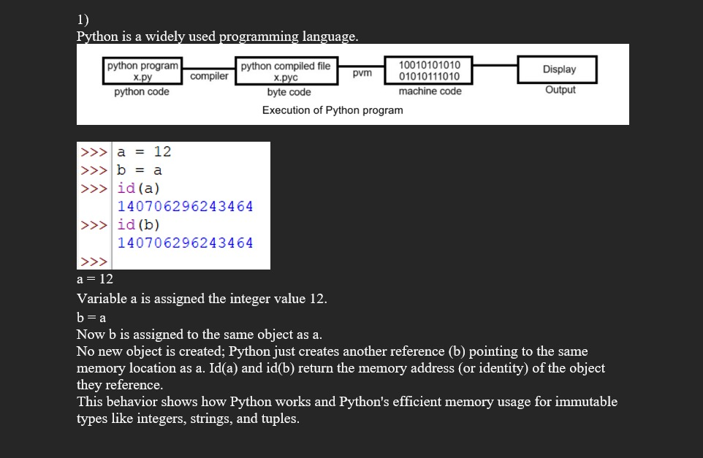

**QUESTION 2**

This program takes 2 inputs from the user and displays the result of various arithmetic calculations like addition, subtraction, multiplication and division

Input and result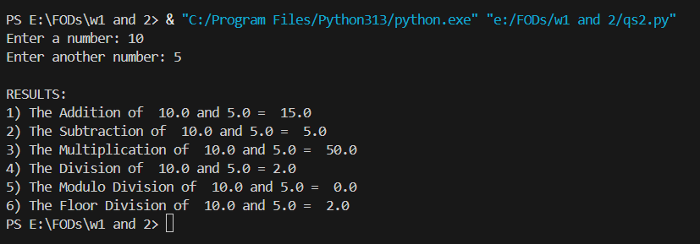

**QUESTION 3**

This program asks the user to input a number and identifies if it’s even or odd. It uses a single algorithm of input, processing and output.

Simple loop of (if_else) has also been used.

**Input and result**

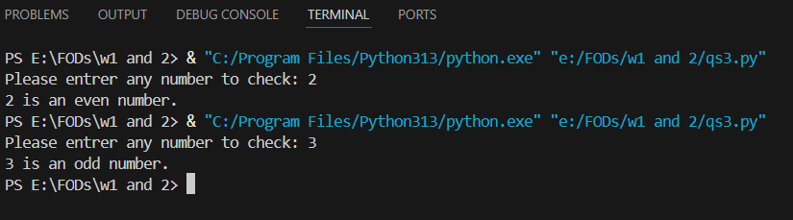

**QUESTION 4**

This program imports one of the modules called math and performs some complex arithmetic operations. Calculations are done and results are printed at last.

**Input and result**

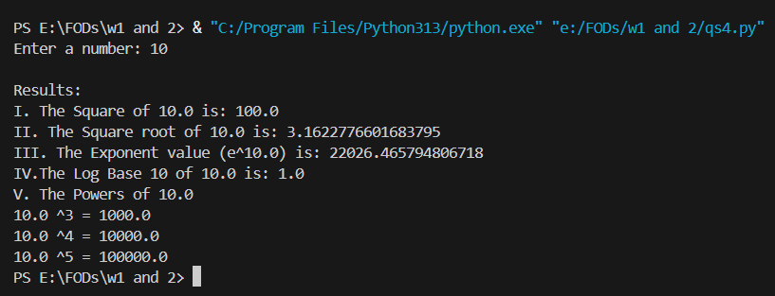

**QUESTION 5**

This program also performs expression relating to power such as a2 + 2ab + b2

**Input and result**

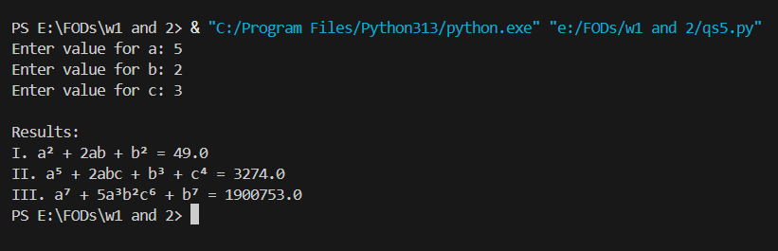

**QUESTION 6**

This program asks the user to enter marks of 5 subjects. After that, it totals it and find average percentage and provides you with grades such as Distinction, 1st Division, 2nd Division etc. accordingly.   
(if_elif) loop has also been used as per the requirement.

**Input and result**

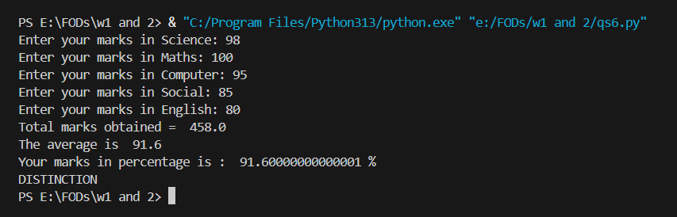

**QUESTION 7**

This program prints prime numbers from the lower limit to upper limit. Both limits are inputted by the user. Nested loops have also been used for the convenience.   
At the end sum of all prime numbers are also printed.

**Input and result**

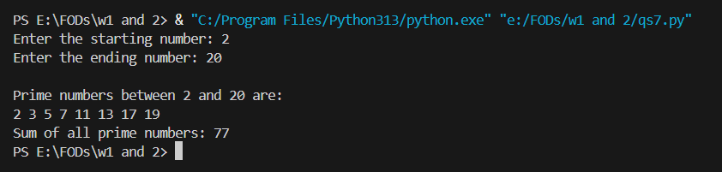

**QUESTION 8**

This program prints the numbers that are divisible by 7 but aren’t divisible by 5 between 2000 and 3200. In range 3201 is used because 3200 is excluded if 3200 is entered. Loops are used as necessary.  
It is also done by asking the user to input the upper and lower limit

**Input and result (fixed numbers)**

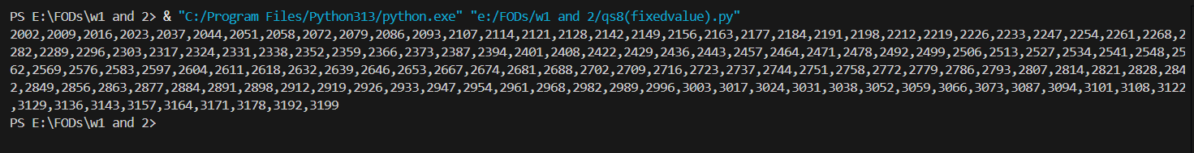

**Input and result (user input)**

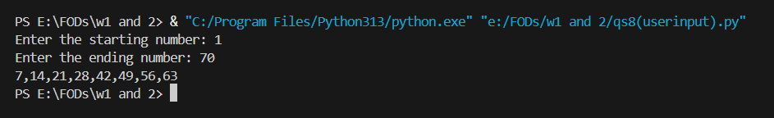

**QUESTION 9**

This program finds a factorial of the input number and prints the result. In case of the input not being a number, it prints “not a number”.

**Input and result**

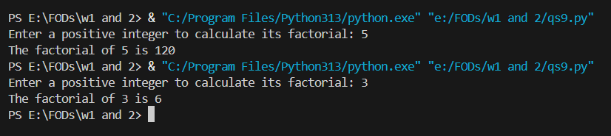

**QUESTION 10**

It’s a menu driven program, where users can input as many numbers as they want, until they decide to end the program. At last, sum of odd numbers and even numbers input are printed.

**Input and result**

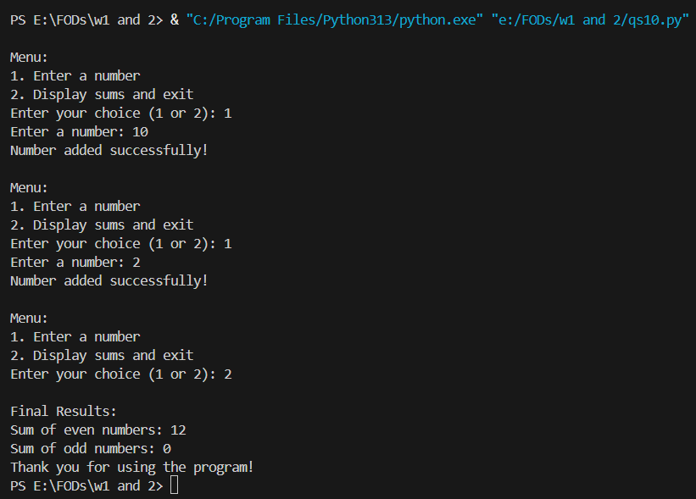

**QUESTION 11**

This program is a simple number guessing game where a random number is chosen and the user has 5 chances to guess the number. The program also provides hints such as “Tow Low” or “Tow High” based on the guess.

**Input and result**

